**ARYAMAN MISHRA**

**19BCE1027**

**FIFO Page Replacement Algorithm**

#include <stdio.h>

int main()

{

int referenceString[10], pageFaults = 0, m, n, s, pages, frames;

printf("\nEnter the number of Pages:\t");

scanf("%d", &pages);

printf("\nEnter reference string values:\n");

for(m = 0; m < pages; m++)

{

printf("Value No. [%d]:\t", m + 1);

scanf("%d", &referenceString[m]);

}

printf("\n What are the total number of frames:\t");

{

scanf("%d", &frames);

}

int temp[frames];

for(m = 0; m < frames; m++)

{

temp[m] = -1;

}

for(m = 0; m < pages; m++)

{

s = 0;

for(n = 0; n < frames; n++)

{

if(referenceString[m] == temp[n])

{

s++;

pageFaults--;

}

}

pageFaults++;

if((pageFaults <= frames) && (s == 0))

{

temp[m] = referenceString[m];

}

else if(s == 0)

{

temp[(pageFaults - 1) % frames] = referenceString[m];

}

printf("\n");

for(n = 0; n < frames; n++)

{

printf("%d\t", temp[n]);

}

}

printf("\nTotal Page Faults:\t%d\n", pageFaults);

return 0;

}

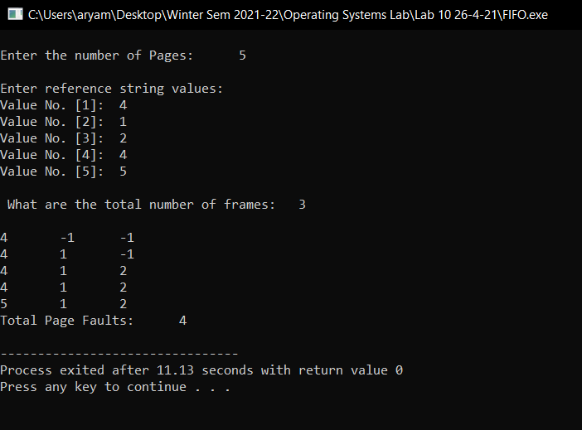

**LRS Page Replacement Algorithm**

#include<stdio.h>

main()

{

int q[20],p[50],c=0,c1,d,f,i,j,k=0,n,r,t,b[20],c2[20];

printf("Enter no of pages:");

scanf("%d",&n);

printf("Enter the reference string:");

for(i=0;i<n;i++)

scanf("%d",&p[i]);

printf("Enter no of frames:");

scanf("%d",&f);

q[k]=p[k];

printf("\n\t%d\n",q[k]);

c++;

k++;

for(i=1;i<n;i++)

{

c1=0;

for(j=0;j<f;j++)

{

if(p[i]!=q[j])

c1++;

}

if(c1==f)

{

c++;

if(k<f)

{

q[k]=p[i];

k++;

for(j=0;j<k;j++)

printf("\t%d",q[j]);

printf("\n");

}

else

{

for(r=0;r<f;r++)

{

c2[r]=0;

for(j=i-1;j<n;j--)

{

if(q[r]!=p[j])

c2[r]++;

else

break;

}

}

for(r=0;r<f;r++)

b[r]=c2[r];

for(r=0;r<f;r++)

{

for(j=r;j<f;j++)

{

if(b[r]<b[j])

{

t=b[r];

b[r]=b[j];

b[j]=t;

}

}

}

for(r=0;r<f;r++)

{

if(c2[r]==b[0])

q[r]=p[i];

printf("\t%d",q[r]);

}

printf("\n");

}

}

}

printf("\nThe no of page faults is %d",c);

}

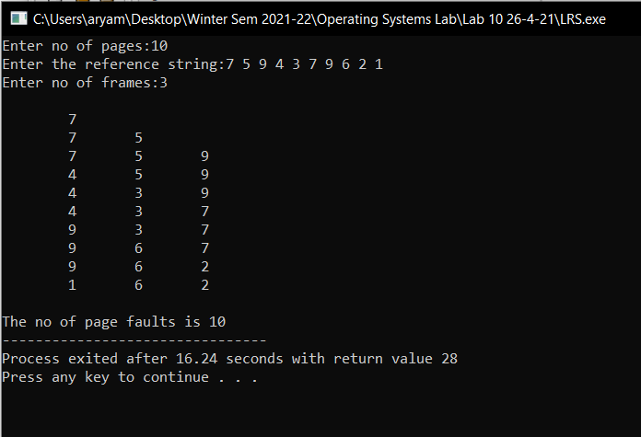

**Extra:Optimal Algorithm**

#include<stdio.h>

int main()

{

int no_of_frames, no_of_pages, frames[10], pages[30], temp[10], flag1, flag2, flag3, i, j, k, pos, max, faults = 0;

printf("Enter number of frames: ");

scanf("%d", &no_of_frames);

printf("Enter number of pages: ");

scanf("%d", &no_of_pages);

printf("Enter page reference string: ");

for(i = 0; i < no_of_pages; ++i){

scanf("%d", &pages[i]);

}

for(i = 0; i < no_of_frames; ++i){

frames[i] = -1;

}

for(i = 0; i < no_of_pages; ++i){

flag1 = flag2 = 0;

for(j = 0; j < no_of_frames; ++j){

if(frames[j] == pages[i]){

flag1 = flag2 = 1;

break;

}

}

if(flag1 == 0){

for(j = 0; j < no_of_frames; ++j){

if(frames[j] == -1){

faults++;

frames[j] = pages[i];

flag2 = 1;

break;

}

}

}

if(flag2 == 0){

flag3 =0;

for(j = 0; j < no_of_frames; ++j){

temp[j] = -1;

for(k = i + 1; k < no_of_pages; ++k){

if(frames[j] == pages[k]){

temp[j] = k;

break;

}

}

}

for(j = 0; j < no_of_frames; ++j){

if(temp[j] == -1){

pos = j;

flag3 = 1;

break;

}

}

if(flag3 ==0){

max = temp[0];

pos = 0;

for(j = 1; j < no_of_frames; ++j){

if(temp[j] > max){

max = temp[j];

pos = j;

}

}

}

frames[pos] = pages[i];

faults++;

}

printf("\n");

for(j = 0; j < no_of_frames; ++j){

printf("%d\t", frames[j]);

}

}

printf("\n\nTotal Page Faults = %d", faults);

return 0;

}

